Git Assignment 4

Master Branch

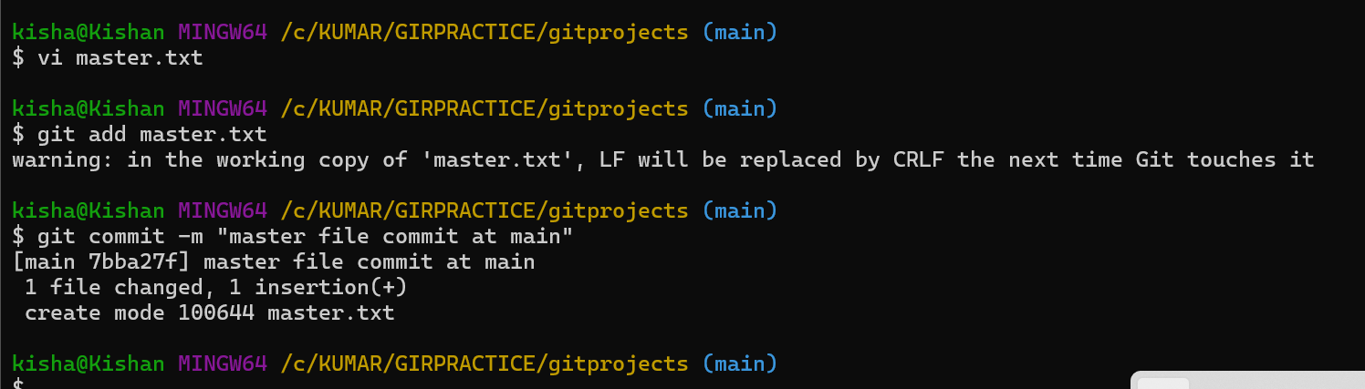

Create Branches

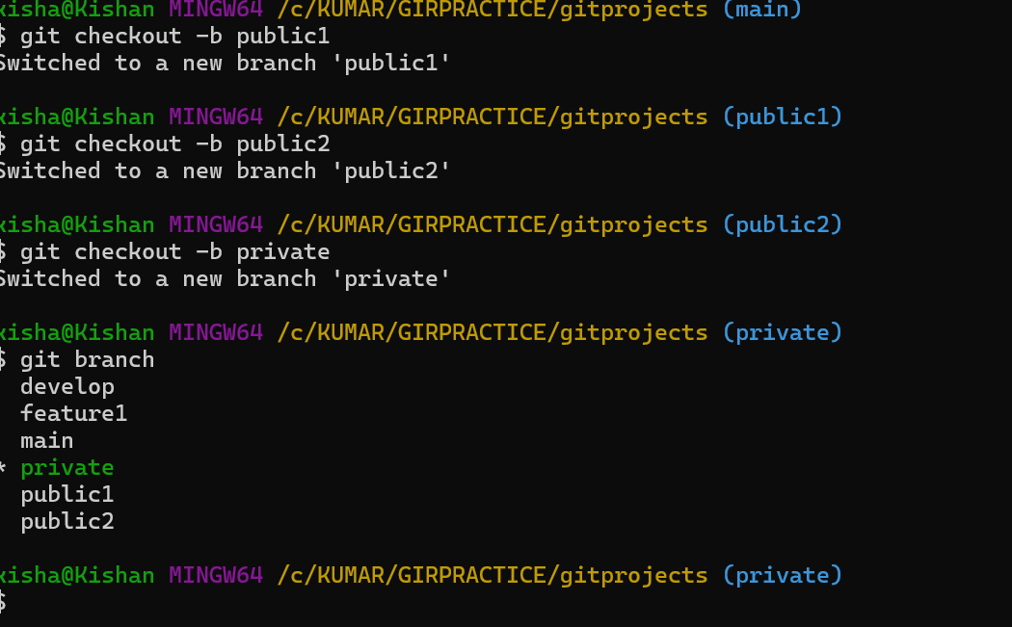

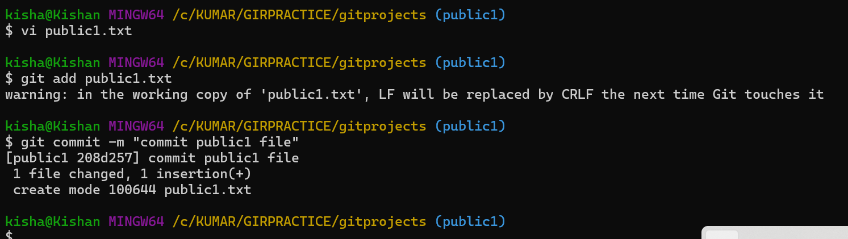

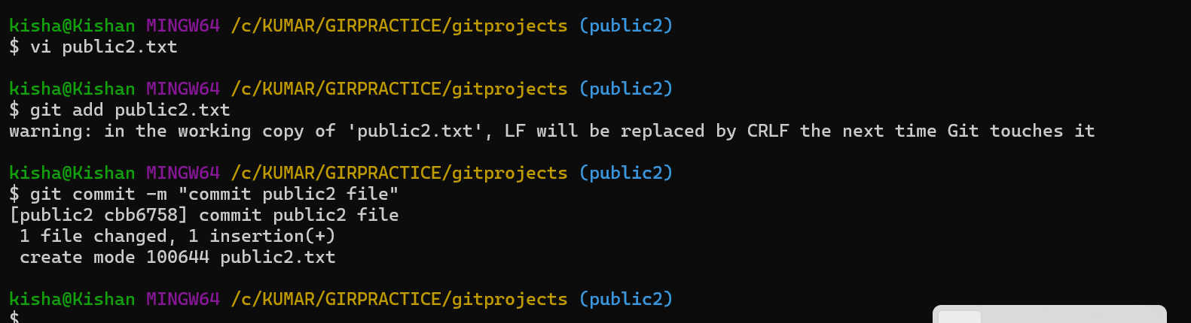

Merging

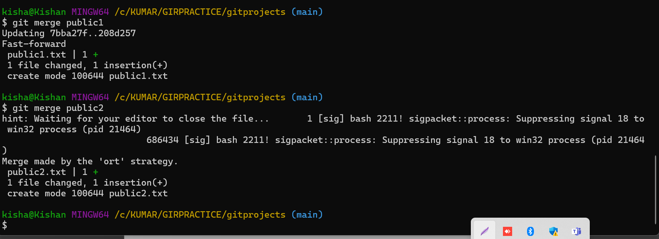

Editing master file

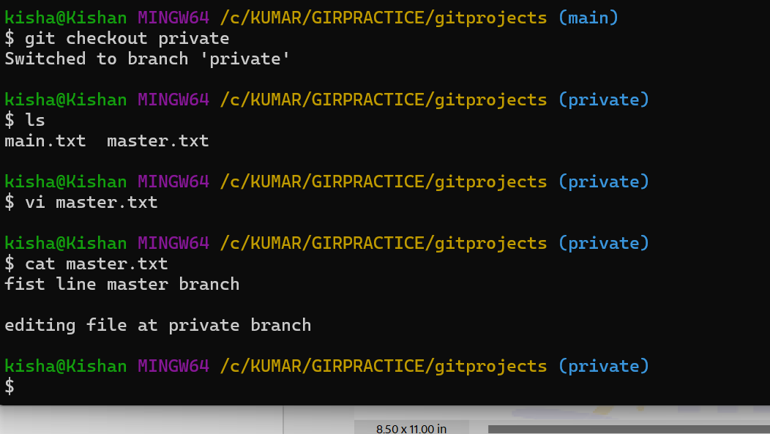

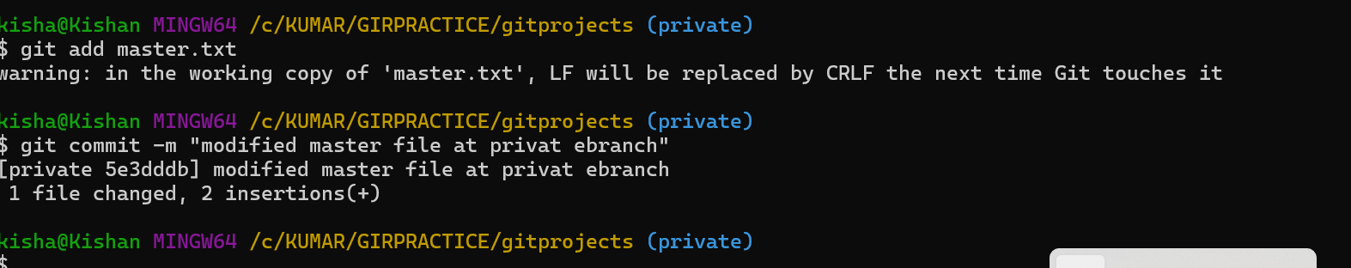

Updating branch

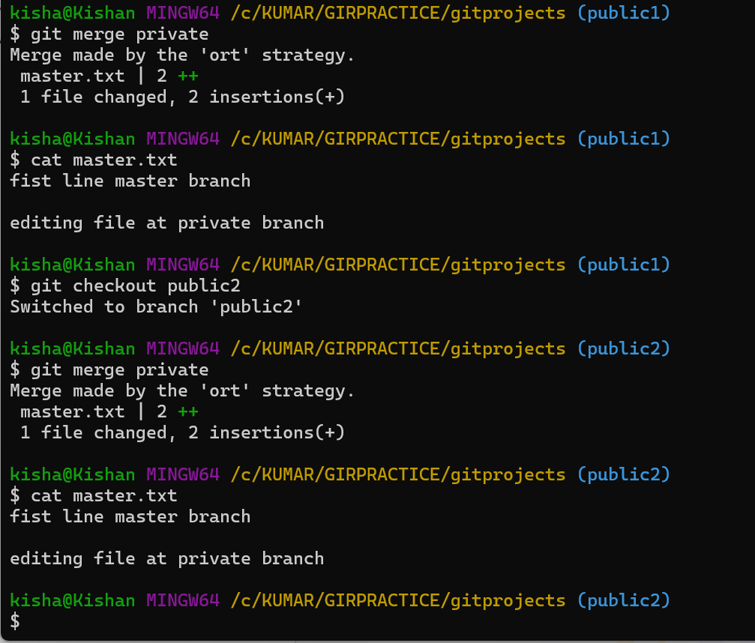

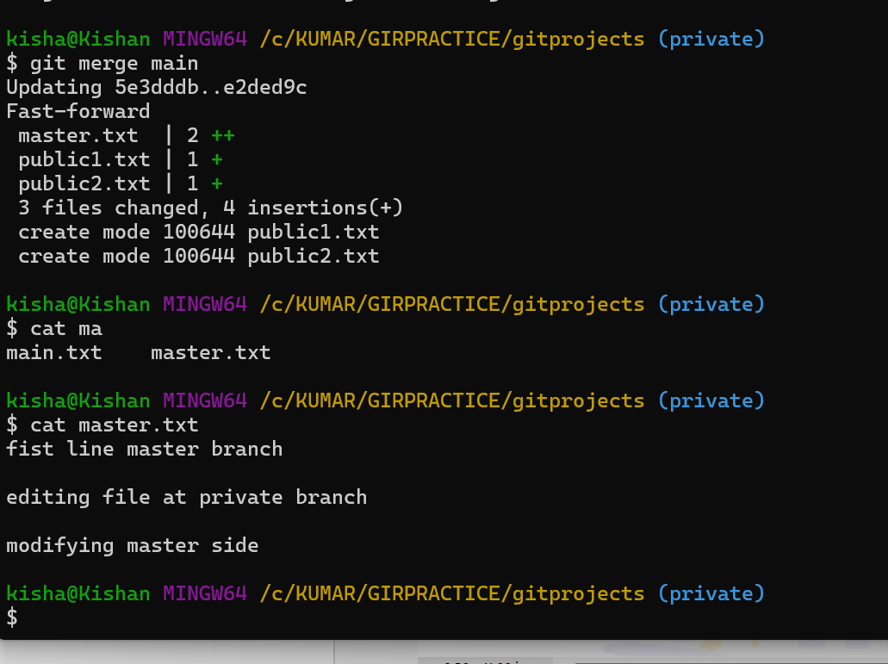

CMDS

$ history

1 branch

2 clear

3 git branch

4 git main

5 git chekout main

6 git checkout main

7 vi master.txt

8 git add master.txt

9 git commit -m "master file commit at main"

10 git checkout -b public1

11 git checkout -b public2

12 git checkout -b private

13 git branch

14 git checkout public1

15 vi public1.txt

16 git add public1.txt

17 git commit -m "commit public1 file"

18 git checkout public2

19 vi public2.txt

20 git add public2.txt

21 git commit -m "commit public2 file"

22 git checkout main

23 git merge public

24 ls

25 git merge public1

26 git merge public2

27 ls

28 git status

29 git log

30 git checkout private

31 ls

32 vi master.txt

33 cat master.txt

34 git add master.txt

35 git commit -m "modified master file at privat ebranch"

36 git checkout public1

37 ls

38 cat master.txt

39 git pull origin private2

40 git pull origin private

41 git fetch private

42 git merge private

43 cat master.txt

44 git checkout public2

45 git merge private

46 cat master.txt

47 git checkout main

48 cat master.txt

49 git merge public1

50 git merge public2

51 cat master.txt

52 vi master.txt

53 git add master.txt

54 git commit -m "modified master file"

55 git checkout private

56 cat master.txt

57 git merge master

58 git merge main

59 cat master.txt

60 history